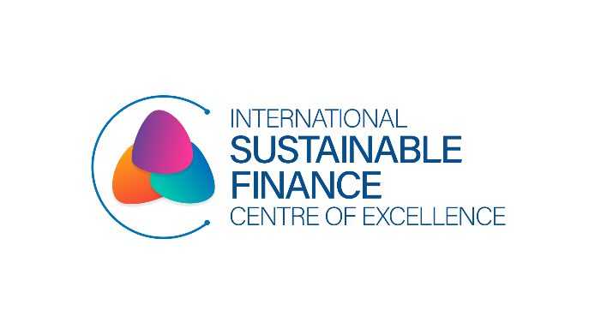

‘Nature Finance Day 2024’
Charting the Course: Accelerating Ireland's Nature of Finance Agenda
International Day for Biological Diversity (IDB) 2024
Wednesday, 22nd May 2024
Euronext, Dublin

Charting the Course: Accelerating Ireland's Nature of Finance Agenda
The catastrophic loss of nature the world is currently experiencing is dangerous for human wellbeing and, as noted recently by the European Central Bank, “[is] also existential for the economy and the financial system, as our economy cannot survive without nature.”
Understanding Biodiversity/Nature Finance:
The time to unlock financing for biodiversity protection is now. The economy operates within the natural world, rather than existing separately from it. This reality brings both substantial risks and opportunities to the financial sector. In recent years, there has been a growing recognition among economic and financial players of the intricate connections between environmental degradation and financial risks to economic activities and the financial system. Nature finance has emerged as a key area of research and a pressing concern for financial institutions. It focuses on understanding how financial and capital markets can function in a way that promotes positive outcomes for nature. The nature finance agenda is therefore guided by the risks and opportunities that arise from the fundamental reliance of the economy on the natural environment.
A new nature-positive economy could generate up to $10.1 trillion in annual business value and create 395 million jobs by 2030. This $10 trillion of business opportunities could be unlocked by transforming the economic systems that are responsible for almost 80% of nature loss: food, infrastructure, energy, and extractives (UNDP).
What is biodiversity risk?
People depend on biodiversity, encompassing genes, species, and ecosystems, for their survival and prosperity. Diverse ecosystems play a crucial role in food production, and numerous medicines originate from natural compounds discovered in plants, animals, and microorganisms. The recent losses of ecosystem services have been estimated to cause damages of USD$4 trillion to USD$20 trillion per year.
In addition to these physical risks, there are ‘transition risks’ from regulatory responses to biodiversity loss. One key example is the recent COP15 conference in Montreal, which led to an international agreement to put 30% of the planet under protection by 2030. These transition risks can have substantial effects on economic activity and asset values.
Despite its significance, biodiversity risk has been insufficiently explored in economic and financial research, partly due to its complexity and the difficulties in measuring it.
Biodiversity and business:
Most of the world's largest companies are significantly dependent on nature in their operations even as the biodiversity and ecosystems underpinning those resources are declining due to overexploitation and climate change. New research from S&P Global Sustainable finds that 85% of the world’s largest companies that make up S&P Global 1200 have a significant dependency on nature across their direct operations.
The analysis also finds that 46% of companies in that universe have at least one asset located in a Key Biodiversity Area (KBA) that could be exposed to future reputational and regulatory risks.
S&P Global 1200 companies used an estimated 22 million hectares of land for their direct operations in 2021 to generate $28.9 trillion in revenue. Measured as an ecosystem footprint, this equates to the complete degradation of 2.2 million hectares of the world's most pristine and significant ecosystems, including the most intact and biodiverse regions of the Amazon or Sumatran rainforests.
The landscape of corporate environmental responsibility is evolving beyond a focus on climate issues to more holistically account for nature-related risks, such as biodiversity loss. Recognising the very real threat to global economies and ecosystems posed by biodiversity loss, prominent global corporations are venturing beyond the atmosphere and into the biosphere.
Enter the Taskforce on Nature-Related Financial Disclosures (TNFD). In January 2024, more than 300 organisations worldwide, spanning various industries and the financial sector, pledged to adopt nature-related disclosures in line with the recommendations put forth by the TNFD, which were released just months earlier. While the advent of the TNFD represents a noteworthy and optimistic advancement, it does not signify the culmination of efforts. Numerous crucial scientific inquiries regarding biodiversity conservation persist unanswered, underscoring the need for ongoing exploration by both the private sector and the scientific community.
Significance of nature and biodiversity for banks and other financial institutions:
Preserving nature and curbing further biodiversity decline hinges significantly on the actions of banks and other financial entities. Pressures such as stricter liability regulations, heightened scrutiny of supply chain practices, and evolving customer preferences are amplifying the importance of roles played by banks, insurers, asset managers, and investors. The financial sector faces mounting public awareness regarding the risks posed by biodiversity loss and the impact of their operations and investments on biodiversity. Banks and other financial
institutions influence biodiversity through the economic activities they facilitate via lending, investment, and insurance. They encounter various risks in this regard, including physical risks—threats to ecosystem services vital for economic activities—transitional risks, such as policy changes or technological advancements aimed at reducing harm to ecosystems, and reputational risks, stemming from negative impacts associated with specific companies they finance, leading to reputational harm for the institutions involved. These risks ultimately translate into financial risks, exacerbating macroeconomic challenges and endangering financial system stability.
Halting biodiversity loss necessitates financing and investing in nature-based solutions (NbS), with private finance playing a crucial role in this arena, known as nature-based finance. Initiatives such as the UN Environment Programme (UNEP), the Economics of Land Degradation (ELD) Initiative, and the World Economic Forum (WEF) explore strategies for wealthy nations to enhance biodiversity protection and conservation, actions that banks, as significant financiers, can champion.
Against this backdrop, central banks around the world are beginning to examine the extent to which nature risks could pose a threat to financial stability. De Nederlandsche Bank (DNB) and Banque de France were some of the first central banks to quantify the extent to which the financial institutions they oversee are exposed to risks from nature and biodiversity loss (Refer to figure 1).
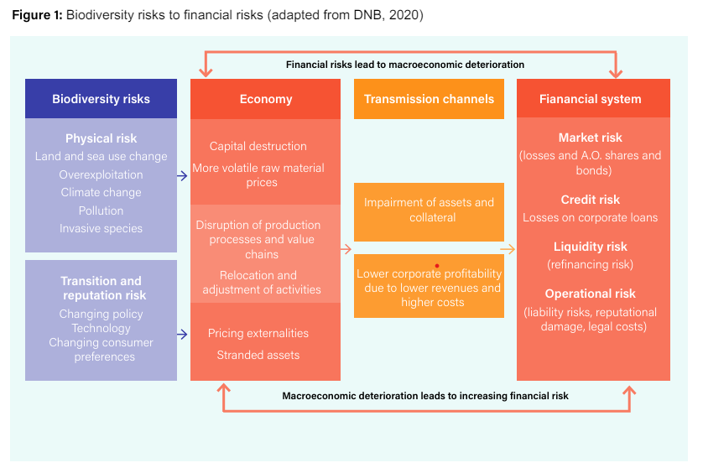
How banks and other financial institutions can contribute to nature protection and biodiversity conservation:
Below are some key actions banks and other financial institutions can take and are taking to contribute to biodiversity conservation and nature protection:
A. Recognize the significance of biodiversity and natural resources for financial stability and the economy. Acknowledge the pressing nature of the biodiversity crisis and its interconnectedness with the climate crisis. Accept responsibility to ensure that their financed activities do not exacerbate ecosystem destruction and species extinction.
B. Actively support and formally align their business operations, policies, regulations, and financial flows to minimize impacts on biodiversity and promote innovative financial solutions for biodiversity and climate. Implement specific policies that prioritize excluding finance for highly impactful activities and prohibit direct or indirect financing related to unsustainable, extractive, industrial, and socially harmful practices in biodiverse areas.
C. Align business operations, policies, and regulations with the relevant targets of the Convention on Biological Diversity (CBD) and the vision of living in harmony with nature by 2050.
D. Promote a nature-positive future through financing, engagement, and partnerships. Strive for a future where biodiversity experiences a net-positive improvement by 2030, with substantial restoration efforts aiming for greater biodiversity by 2050.
Alignment with Ireland’s Sustainable Finance Roadmap:
To support the goal of Ireland becoming a leading sustainable finance centre by 2026, the International Sustainable Finance Centre of Excellence (ISFCOE) was established. Aligned with government policy outlined in Ireland for Finance Strategy 2025, Irish National Sustainable Finance Roadmap and Climate Action Plan 2022, the establishment of the Centre of Excellence is Action 1 of Ireland’s Sustainable Finance roadmap. This Roadmap is constituted of five pillars and 18 actions. And, action related to advance biodiversity and nature-related efforts was clearly stated in:
- Action 3 (Pillar: Developing Talent) - Support international sustainable finance, biodiversity and nature-related capacity-building endeavours, and
- Action 8 (Pillar: Industry Readiness) - Conduct analysis of the risks and opportunities for the biodiversity finance agenda.
The journey of ISFCOE regarding Biodiversity/Nature Finance:
In December 2023, the International Sustainable Finance Centre of Excellence (ISFCOE) through support from Skillnet Ireland, commissioned a report titled, ‘The Nature of Finance’. This report was authored by KPMG Sustainable Futures and is understood to be the first independent assessment of nature-related risks and opportunities for Ireland’s financial sector. It is hoped that this study will raise awareness of how the sector both impacts and depends on nature, and spurs further detailed research into how these links to nature can generate both risks and opportunities for Ireland’s economy and society. This report was a follow-up to the scoping study that ISFCOE conducted in 2022, titled, ‘Nature and Biodiversity Finance: Risks and Opportunities for Ireland’. Both reports have presented a unique set of opportunities for both private and public sector financial actors and businesses in Ireland. We are also advancing efforts in the space through ‘Communities of Practice’ discussions and by working on developing a course for finance professionals on Biodiversity Finance.
Ireland’s opportunity:
Currently, the public sector is the more prominent actor in nature-based and biodiversity finance, offering financial instruments that would encourage businesses to advance conservation outcomes through tax breaks and other incentives. The State also has a critical role in attracting foreign direct investment as capability and critical mass of expertise emerges.
Given the scale and complexity of nature-related financial impacts, risks, and opportunities and how nascent this agenda is in Ireland, the 2023 report has proposed a draft Nature Finance Roadmap to position Ireland as a leader on the nature finance agenda. The Roadmap mirrors Ireland's Sustainable Finance Roadmap and is structured around five main pillars: 1) Developing talent; 2) Improving industry readiness; 3) Leveraging digital and data; 4) Creating a nature positive enabling environment; and 5) Enhancing communications and engagements on nature and finance risks and opportunities. The Roadmap also proposes an additional Pillar 0 – the establishment of a Nature Finance Roadmap Delivery Group. The role of this Delivery Group will be to take the proposed roadmap and further develop the actions, assign lead organizations and individuals, and agree on the delivery timelines.
The bigger picture for these interventions and discussions is to take forward all these discussions to weave into a biodiversity/nature finance strategy going forward.

https://publications.banque-france.fr/sites/default/files/medias/documents/wp826_0.pdf
https://www.undp.org/nature/our-work-areas/biodiversity-finance
https://www.spglobal.com/esg/insights/featured/special-editorial/how-the-world-s-largest-companies-depend-on-nature-and-biodiversity
https://www.spglobal.com/esg/insights/featured/special-editorial/how-the-world-s-largest-companies-depend-on-nature-and-biodiversity
https://ssir.org/articles/entry/biodiversity-loss-business-TNFD#
https://tnfd.global/
https://www.charteredbanker.com/resource_listing/cpd-resources/the-meaning-of-nature-and-biodiversity-for-banks.html
https://isfcoe.org/landmark-nature-finance-report/
https://www.charteredbanker.com/resource_listing/cpd-resources/the-meaning-of-nature-and-biodiversity-for-banks.html
https://isfcoe.org/wp-content/uploads/2024/04/F9ysNG-Irish-SusFinance-Roadmap-FINAL-FINAL-OCTOBER-2021.pdf
https://isfcoe.org/wp-content/uploads/2023/12/KPMG-ISFCOE-Dec-23-Final-Ebook-3-MASTER-v3.pdf

